WOMEN IN SCIENCE

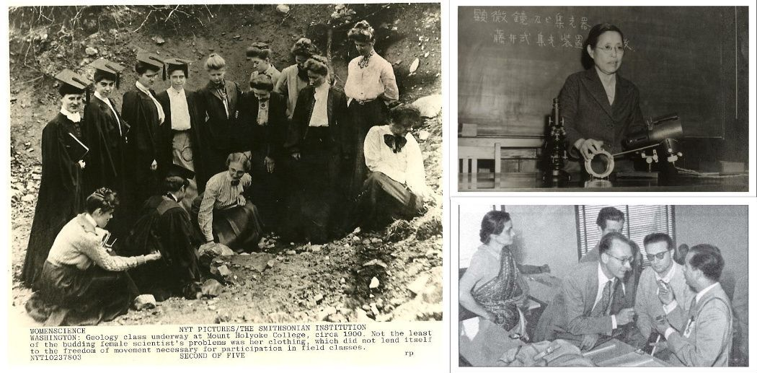

Instructor
Dr Amelia Bonea

Course description
The underrepresentation of women in science, both at the level of education and employment, is a persistent global problem that has been recognized as such by international organizations and national governments alike. Apart from the socio-economic and cultural barriers that prevent women from pursuing scientific careers, the invisibility of women in science is further accentuated by media biases that tend to portray science as a male domain. This module attempts to challenge such perceptions by showing that women have always played an important part in histories of science across temporal, geographic and cultural divides. How can we recover and study the manifold histories of women in science? In attempting to answer this question, we will focus on the activity of established women scientists from Asia, Europe and other parts of the world, but also on the many hidden actors who have worked outside or at the periphery of scientific communities, including as wives and sisters of male scientists, traditional healers, administrators, collectors, writers, photographers, journalists, etc.

Grading
Your grade will be assessed as follows:
► Attendance and participation in class discussion: 25%
► In-class presentation: 35%
► Final essay: 40%
NB: The final essay should be about 3,000 words (4 credits) OR 6,000 words (8 credits).

In order to participate effectively in class discussion, you should read the assigned texts for each week, paying particular attention to the following questions:
1. What are the major themes discussed in these readings?
2. What aspects of the arguments presented by the author(s) do you agree/disagree with?
3. What questions would you like to raise for discussion in class?
For the presentation, you are required to use the materials assigned for a particular session and any other materials of your choice in order to reflect on the following question:
- How should we study the history of women in science?

For the final essay, you have the following choices (please consult with the instructor if you need any help):

- Identify a topic of interest (e.g. historical background to the underrepresentation of women in science in a particular country, women and the popularization of science, women and field sciences, gender, science and empire, etc.) and write an essay making use of primary and secondary literature.
- Write the “biography” of a woman in science (NB: This does not necessarily have to be a woman scientist, but can also focus on other, little recognized categories of scientific workers, including computers, technicians, journalists, administrators, etc.).
- Follow a news story that engages with the topic of women in science and analyze it by drawing on some of the theoretical and methodological approaches discussed in class. You may use a variety of media for this purpose, e.g. newspapers, films, images, music, etc.

Session 1: (Writing) Women, Gender and Science
L. Schiebinger, The Mind Has No Sex? Women in the Origins of Modern Science, Ch. 10 “The Exclusion of Women and the Structure of Knowledge”
L. Jordanova, “Gender and the Historiography of Science”

Session 2: Science, Gender and Empires
L. Schiebinger, “Feminist History of Colonial Science”
S. Harding, Sciences from Below: Feminisms, Postcolonialities, and Modernities, Ch. 5, “Postcolonial Science and Technology Studies: Are There Multiple Sciences?”

Session 3: Archives of Science
Fisher and Henningsen, “Women in Science through an Archival Lens”
Chowdhury, “A Historian among Scientists: Reflections on Archiving the History of Science in Postcolonial India”

Session 4: Women and early modern scientific cultures
P. Fara, Pandora’s Breeches: Women, Science and Power in the Enlightenment, Ch. 1 “Women/Science”
M. K. Ray, Daughters of Alchemy: Women and Scientific Culture in Early Modern Italy, Ch. 4 “Scientific Circles in Italy and Abroad”

Session 5: Women and the popularization of science
B. T. Gates, Kindred Nature: Victorian and Edwardian Women Embrace the Living World, Ch. 2 “Retelling the Story of Science”
R. Higgitt and C. W. J. Withers, “Science and Sociability: Women as Audience at the British Association for the Advancement of Science, 1831-1901”

Session 6: The politics of science education
Sheffield, Women and Science: Social Impact and Interaction, Chapter 4
V. Poonacha, “Uncovering the Gender Politics of Science Policies, Education, and Institutional Practices,” in N. Kumar (ed.), Women and Science in India: A Reader

Session 7: Science and Gender in the Field I
L. Schiebinger, “The Private Life of Plants: Sexual Politics in Carl Linnaeus and Charles Darwin”
V. Damodaran, “Gender, Race, and Science in Twentieth-Century India: E. K. Janaki Ammal and the History of Science”

Session 8: Science and Gender in the Field II
M. Kölbl-Elbert and S. Turner, “Towards a History of Women in the Geosciences”
C. V. Burek and M. Kölbl-Elbert, “Historical Problems of Travel for Women Geologists”
P. N. Wyse-Jackson and M. E. Spencer Jones, “The quiet workforce: the various roles of women in geological and natural history museums during the early to mid-1900s”

Session 9: Science and Gender in the Laboratory
S. Traweek, Beamtimes and Lifetimes: The World of High Energy Physics, Ch. 3 “Pilgrim’s Progress: Male Tales Told during a Life in Physics”
Abha Sur, “Dispersed Radiance: Women Scientists in C. V. Raman’s Laboratory”

Session 10: Science and Gender in the Home
J. Behrmann, “Domesticating Physics: Introductory Physics Textbooks for Women in Home Economics in the United States, 1914-1955”
H. N. Schneider, Keeping the Nation’s House: Domestic Management and the Making of Modern China, Ch. 3 “Domestic Discipline”

Session 11: Gender, Medicine and Health
G. Forbes, “No ‘Science’ for Lady Doctors: The Education and Medical Practice of Vernacular Women Doctors in Nineteenth Century Bengal”
Y. Terazawa, Knowledge, Power, and Women’s Reproductive Health in Japan, 1690-1945, Ch. 5 “Women’s Health Reforms in Japan”
Alison Bashford, ‘Medicine, Gender, and Empire’ in Philippa Levine (ed.), Gender and Empire (Oxford, 2004), pp. 112-133

Session 12: Gendering Technology
J. Wajcman, Feminism Confronts Technology, Ch. 6 “Technology as Masculine Culture”
A. Stanley, Mothers and Daughters of Invention: Notes for a Revised History of Technology, Ch. 5 “Daughters of the Enchantress of Numbers”

Session 13: Technicians and other “lesser” scientists
Hartley and Tansey, “White Coats and No Trousers: Narrating the Experiences of Women Technicians in Medical Laboratories, 1930-90”
Light, “When Computers Were Women”

Session 14: Concluding discussion

